Ideation Phase

Navigating Flight-Booking-app Template

Date | 31 January 2025
Team ID | LTVIP2025TMID52738
Project Name | Navigating Flight-Booking-App
Maximum Marks | 4 Marks

Navigating Flight-Booking-App& Idea Prioritization Template:
Creating a flight booking app involves streamlining complex travel information into a clear, intuitive user interface that supports seamless navigation across devices. An effective app design should enable users to easily explore available flights, filter results, manage bookings, and complete secure transactions. During brainstorming, the emphasis should be on creating user-centric navigation patterns—such as logical menu structures, real-time search suggestions, and simplified checkout flows. Prioritizing usability over complexity allows for the development of a smart and accessible platform. Teams are encouraged to collaborate creatively and iterate rapidly to deliver a frictionless travel booking experience.
Use this template to map out your app’s navigation and user flows collaboratively, whether
you're working remotely or in person.
Reference: https://ui8.net/slabdsgn/products/the-flight---flight-booking-app-ui-kits— Flight Booking App UI Kit (for design and navigation planning)

Step-1: Team Gathering, Collaboration and Select the Problem Statement
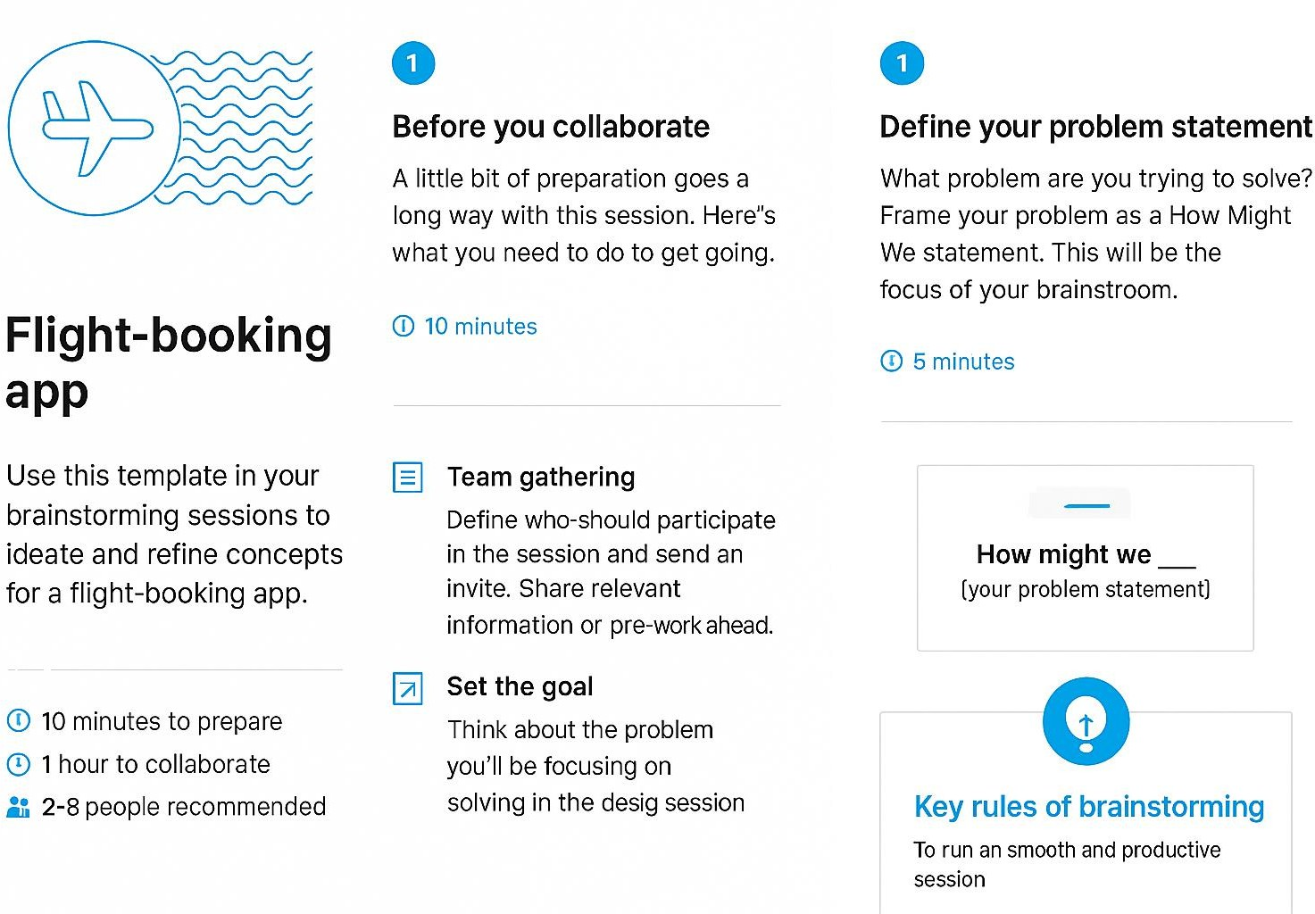

Step-2: Flight-Booking-App, Idea Listing and Grouping
The flight booking ER-diagram represents the entities and relationships involved in a flight booking system. It illustrates how users, bookings, flights, passengers, and payments are interconnected.
Here is a breakdown of the entities and their relationships:
USER: Represents the individuals or entities who book flights. A customer can place multiple bookings and make multiple payments.
BOOKING: Represents a specific flight booking made by a customer. A booking includes a particular flight details and passenger information. A customer can have multiple bookings.
FLIGHT: Represents a flight that is available for booking. Here, the details of flight will be provided and the users can book them as much as the available seats.
ADMIN: Admin is responsible for all the backend activities. Admin manages all the bookings, adds new flights, etc.

Step-3: Idea Prioritization

Idea | Importance | feasibility | Position grid
Real-time Flight  Tracking | High | Medium | Top-left quadrant
One-click Booking | High | High | Top-right quadrant  ⬛
Live Chat Support | Medium | High | Mid-right
Voice Search for  Flights | Medium | Low | Bottom-left
Loyalty Points  Integration | High | Medium | Upper-mid

